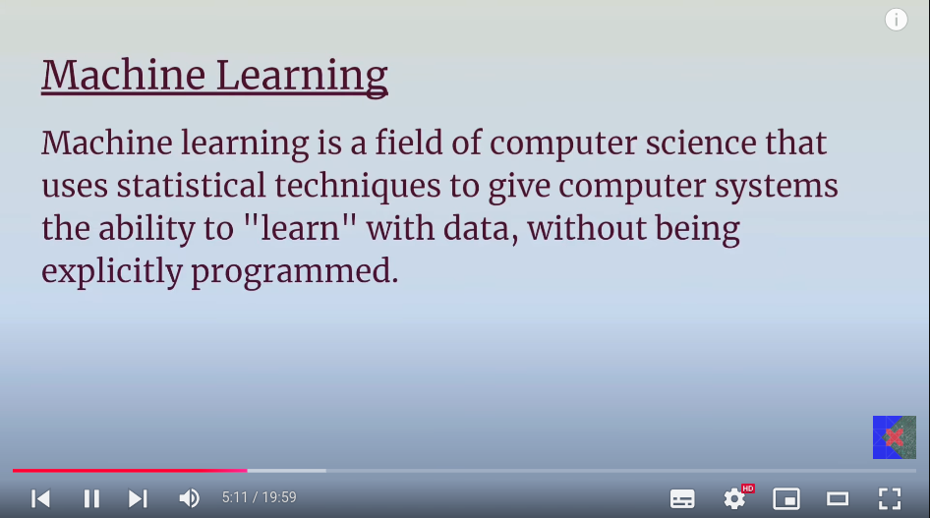
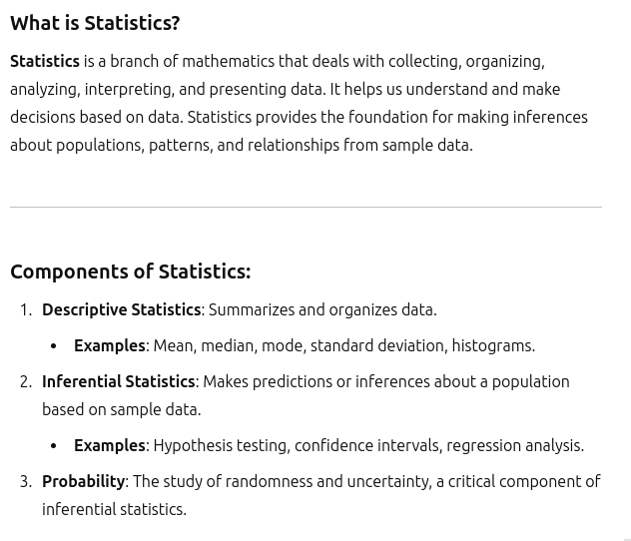
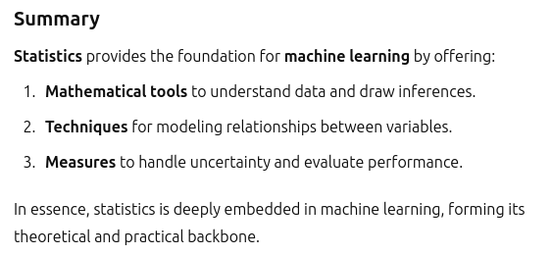
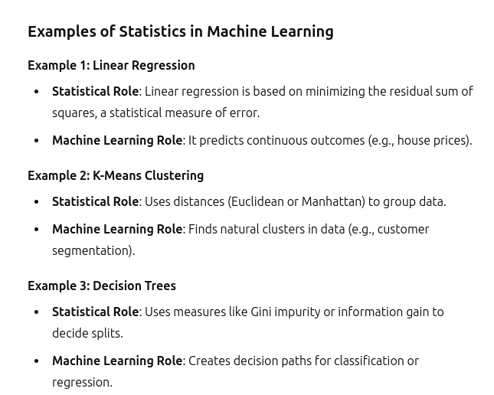
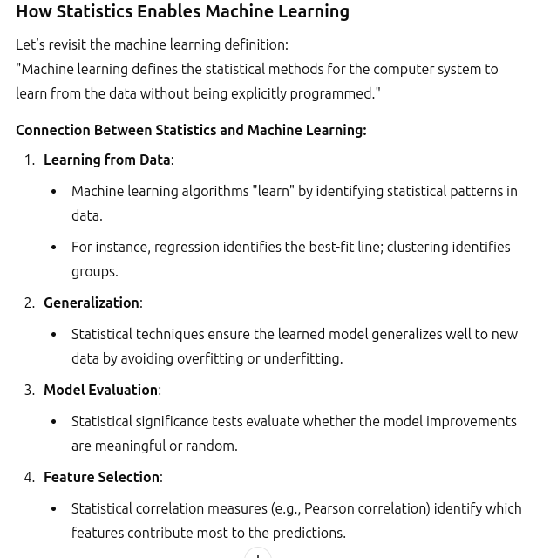
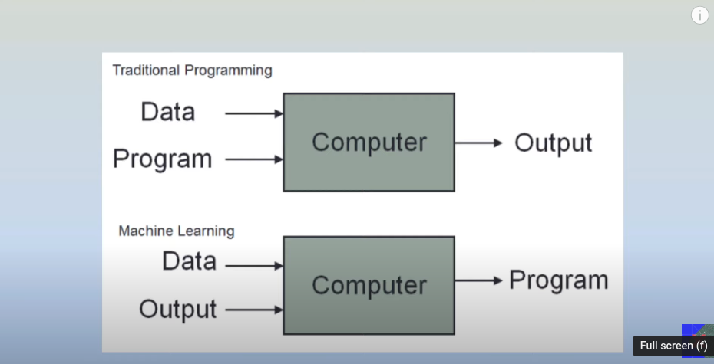
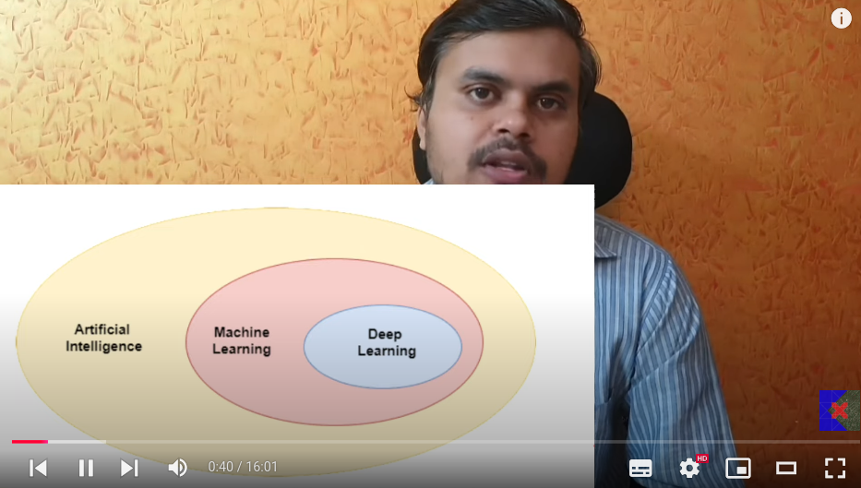

- Intelligence:
  - Pattern recognition( MOST AI stuffs)
  - creativty , imagination
  - Emotional intelligence
- Symbolic AI - hell lot of if else condtions.
- Expert systems:
  - Extracted from symbolic AI
  - The knowledge base is taken from the Expert
  - 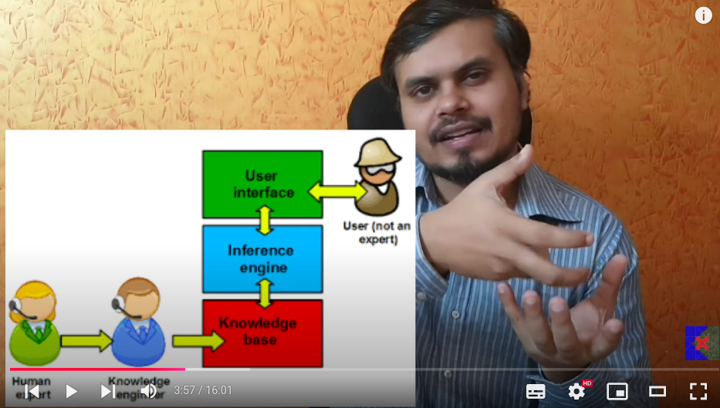
  - Expert systems are just the extension of symbolic AI, if the dogs picture is given then including many features is not actually possible. - just the fuzzy logic.
  - Hence ML introduced.
- In machine learning we have to explicitly give the featrues. But deeep learnig has got the capacity to extract the features by itself, but need enormous amount of data.
  - 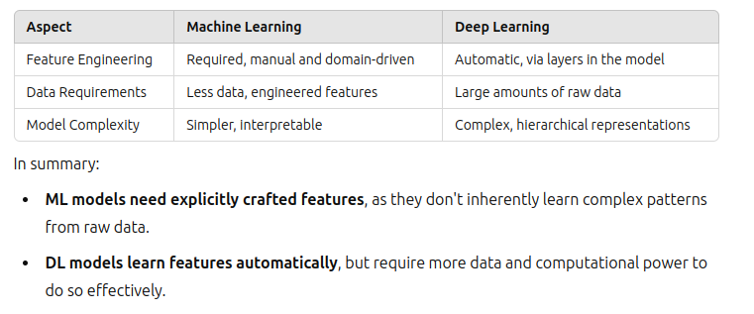
  - 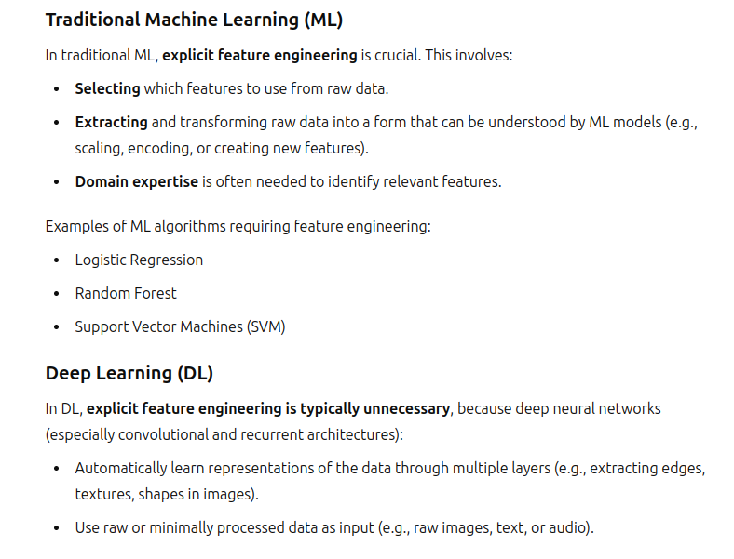
  - Deeper the network, greater power for making the task.
  - 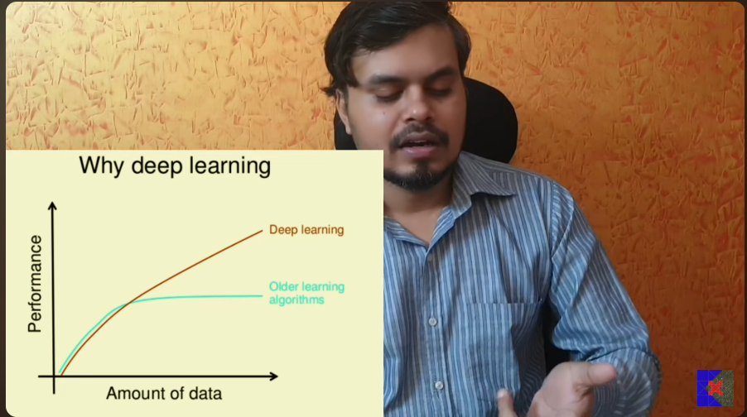
  - Deep learning is useful onlt when there is lot of data. For small data machine learninng is good.

- Day 3 - Types of Machine learning:
  - 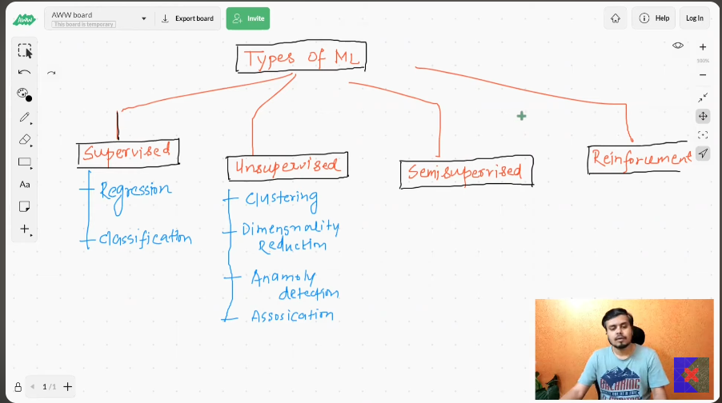
  - Supervised machine learning(ip and op):
    - Make the relation between the input and output.
    - 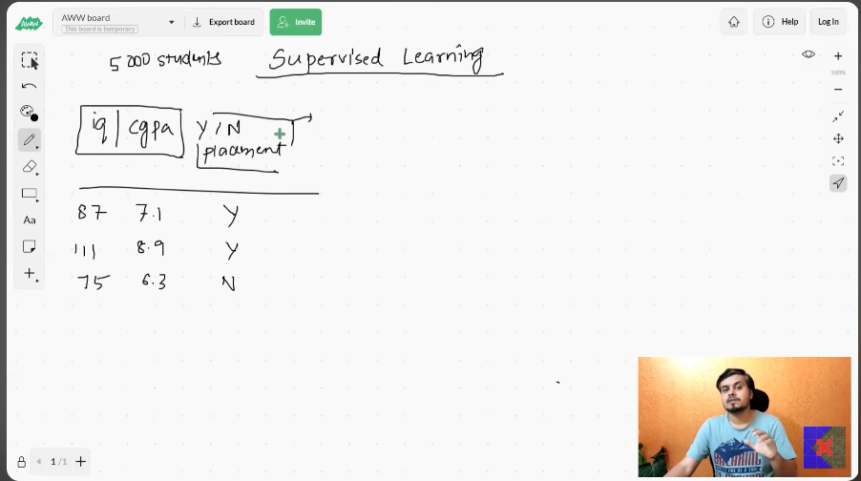
    - types - regression(output is numerical) and classification(output is categorical).
    - data - numerical and categorical data.
  - Unsupervised machine learning(only op):
    - only input no output.
    - Clustering, Dimensionlation dreduction, Anamoly detection, Association rule learning. These are the things that can be done.
    - 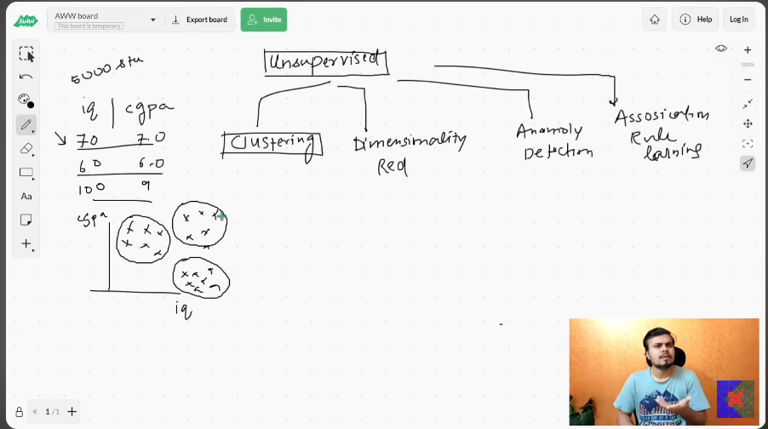
    - clustering- iq, cgpa. the broadly classified categories are. 00,01,10,11.
      - Above is just the 2d data. But the clustering algorithm works in N-dimensional data.
    - Dimensioanlty reduction-
      - Suppose you have 100 columned data
        - ML algorithm runs very slowly.
        - Too many inputs.
        - After some columns, the results will not improve even after including those columns into my data.
        - So dimensionality reduction will remove the non important columns.
        - So from the many columns, it reduces to very important data.
        - Plotting data, from 1000d to 2d-3d data.
        - MNIST dataset, in 3D data.
        - 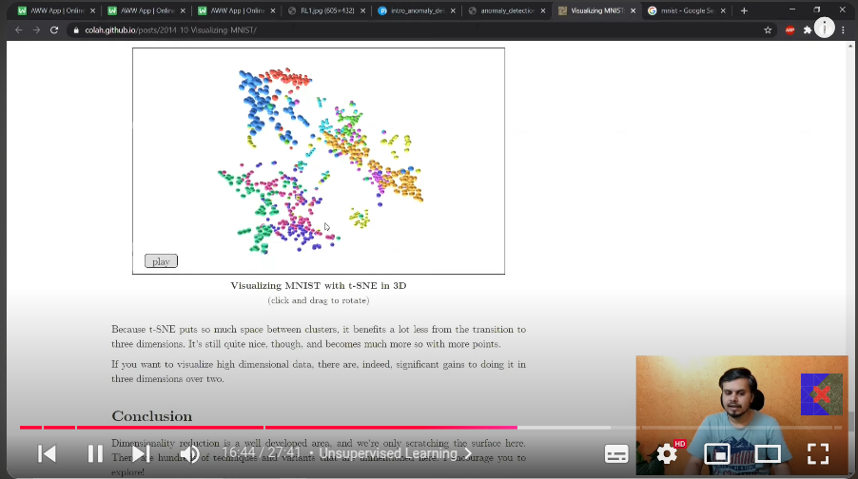

    - Anamoly detection:
      - If there is any outlier in the input, it is used for detecting , and removing that.
      - 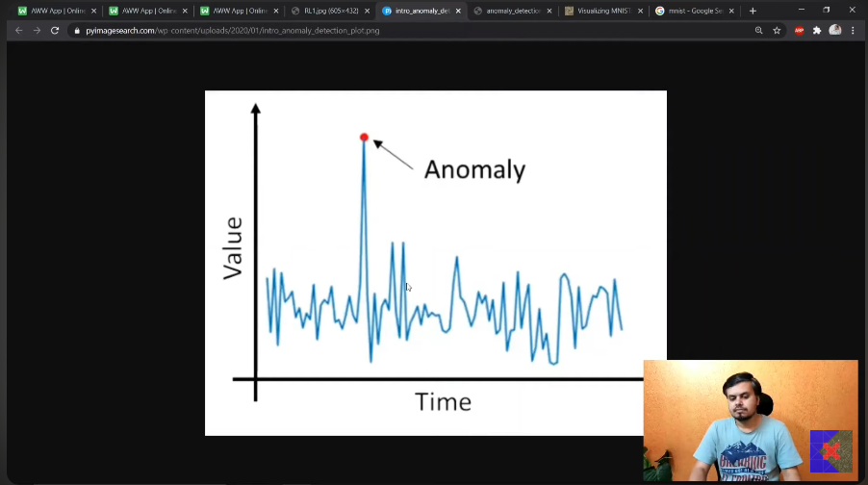
    - Association rule based learning:
      - In big bazar how do you know which element to place at which position.
      - There are hell lot of elements in it, but how to arrange them in the sequence. Such that buying happens more.
      - Association - Suppose you started to get the bills, Then you get to know, if 100 times milk is bought then 60 times eggs are taken along with the milk.
      - So keeping eggs and milk side by side, will make the customer to spend too muxh time in commuting between the places. Hence the time spent by the consumer is more on product rather than moving around, may increase the sales.
      - The best use case is keeping the bear bottles beside the Dipers, which had strong correlation in markets. Wlamrt.
  - Semi supervised learning:
    - To label the data need the human intervention, which costs too much of money.
    - So identify some pattern in the data once(human intevention) , then automatically the labelling should happen by itslef(machine or algorithm), by just looking at the data.
    - Ex: Google photos.
  - Re-inforcement learning(No data):
    - There is agent, which has to live in some environment
    - 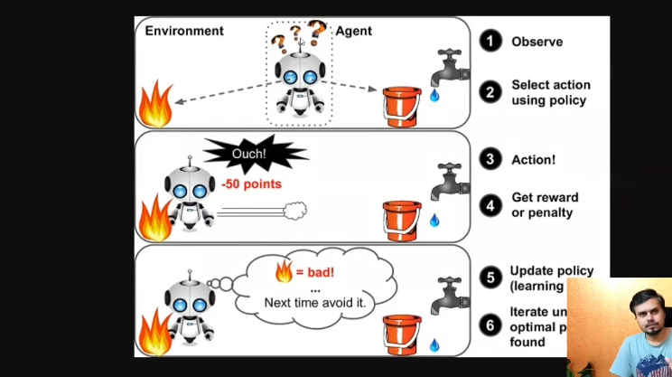
    - Agent has policy, the rules, positive reward and negative reward.
    - When agent goes to desired environment, then you will give the positive reward, else you will give the negative reward.
    - GO - Deep Mind.

- How does the machine learning model is trained epecially when it deployed on server.(PRODUCTION) [important]
  - Production environment- where the machine learning models are deployed for the inference. Server running environment.
  - developement environment- where we code for buiding the model, code is built, is called as the development enviromment.
    - Batch / offline machine learning :
      - You will use all the data at a time to train the model.
      - No incremental training, not by splitting the data small by small and then training the model.
      - If you are training the model with huge data when deployed in the server:
        - Costly
        - time consuming
      - So training with huge data is done locally. Afetr building model, we give it for production.
      - 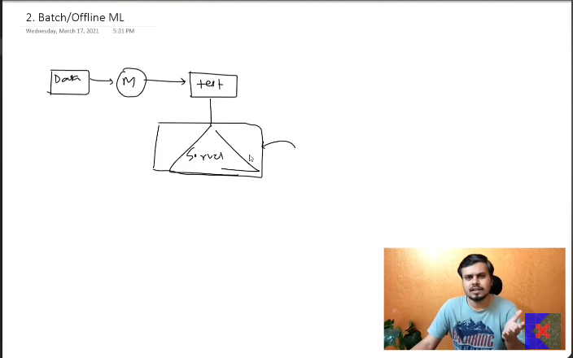
      - Problem:
        - The model keep runnign with the reviouly trained data, it will not evolve as the time progress.
        - To make it up to date, we need to build the model locally again then push that model once again into the server.
        - Need to kee the model up to date.
        - Ex:
          - Recommendation engine in Netflix, each and everyday new movies keep adding to my server.
          - Spam classifier email.

        - 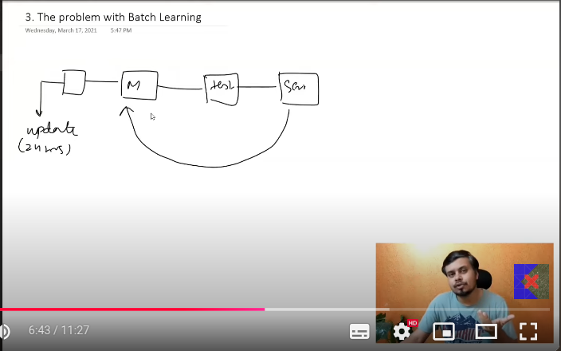
        - No incremental learning.
        - 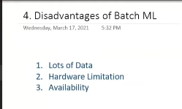
        - Scenarios:
          - Where there is no need to updating the models again and again.
            - Drones
            - Satelites
        - Suppose the demonetization sudden news spikes. Needed that feed in my social media, but if the models is updated for 24 hrs, how the model gets to know when to feed you.
        - Batch learning is not helpful.

    - Online machine learning -
      - Have you listened - “How many number of time you use our product that many times my models performance increase by any comapany”.
      - So on server, everyday based on the information you provide the machine keeps learning frequently.
      - definition: Training to be done incrementally in the server, sequentially. Hence called online learning.
      - Hence the model is learning and predicting at a time.
      - Dynamic predicting.
      - Ex:
        - Chatbots.
        - Yotube.
      - Official -
        - incremental learning, using mini batches of data.
        - training the models sequentially, mini batches.
      - When to use:
      - 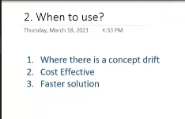
      - When data keeps changing fastly and you need to update the models frequenlty. So at that point of time, you need to update the models, so uses the online training, online machine learning.
      - Cost effective - online learning, since it works on small chunks of data.
      - Faster solution - online learning.
      - 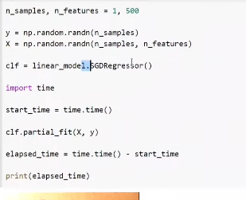
      - 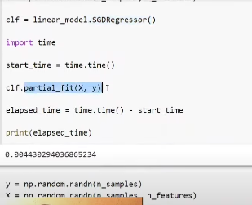
      - River - online python library online learning, it is a merger between creme and scikit-multiflow.
      - vowpal wabbit - a python library, RL and online machine learning.
      - Scikit also supports for online machine learning, but main focus is only on the batch learning.
    - Learning rate :
      - data keeps coming frequently, but how frequently you are training the data to the model??
      - Trade off between, when to learn and what time to learn. Suppose , if you are focusing on 1 micro second , the amount of data generated to you might be low, not soo great.
    - Out of core learning:
      - A technical limitation, we cannot train the model once by using the batch learing.
      - Data is so huge we cannot load the data into the memory at once.
      - So, divide the data into small piece and make the models to learn in batch, hence online learning.
      - 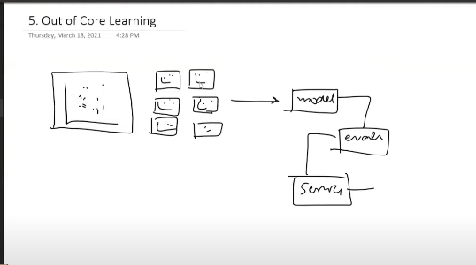
      - Even though this comes under the batch learning , it is similiar to the online learning.
    - Disadvantage:
      - 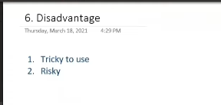
      - 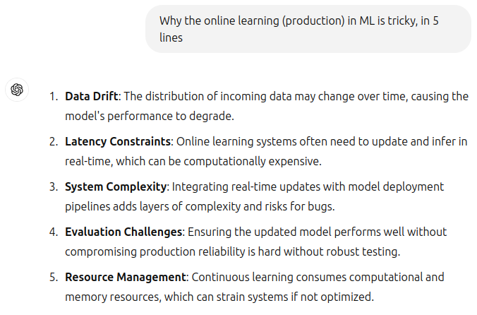
      - based on the incoming data, the model is trained, what of the incoming data is handled by someone else.
      - So to prevent from the above need to build the evaluation system, and need to keep the anamaly detection algorithms. So, by using this we can remove the data from training, somehow do something and protect the model .
      - Eventhough the problems are created then go back to the previous versions.
      - 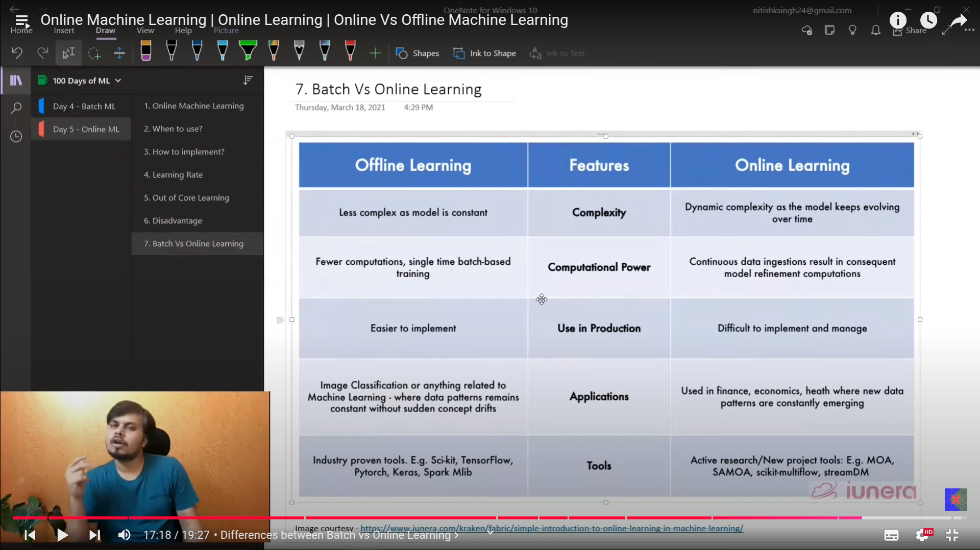

- s

